In the modeling part, we are mainly working on simulating the function of the fermentation system at different levels and serving suggestions for future implementation. The work consists of two parts, flux balance analysis (FBA) and diffusion model of alginate beads considering bacterial metabolism, specifically, the photosynthesis of *Synechococcus sp.,* the formaldehyde degradation function, and sucrose hydrolysis by two types of *e. coli*.

1. Flux Balance Analysis (FBA)

The first part is about flux balance analysis, an approach for studying a genome-scale metabolic network, containing almost all known metabolic reactions, genes, and related enzymes for an organism (Orth, 2010). The reason we chose this approach as the simulation part is not only there were existed reconstructed microorganism models, but also through dynamic FBA and some well-developed toolboxes such as COBRA (Heirendt et al., 2019) and COMETs (Dukovski et al., 2021), we can track the changes in metabolite concentrations in the presence of complex reactions within microbial bodies, and even simulate the co-cultivation of blue algae and e. coli.

* 1. Verification

First of all, we need to verify the model. We search for the existing E. coli Bl21 growth experiment data (Christensen & Eriksen, 2002) to compare with the chosen model iB21_1374 (Monk et al., 2013). We adjusted the intake limitation of glucose intake of the model to restrict it from unlimited nutrient intake, and the simulation result is presented below.

Table 1. Specific rates of growth and yield coefficients for growth of *E. coli* BL21 on glucose as carbon substrate.

| **Parameters** | **Reference value** | **Simulation value** |
| --- | --- | --- |
| $μ$ (gDW)($h^{-1}$) | 0.38 $±$ 0.03 | 0.3796 |
| $$Y_{x/glc}({gg}^{-1})$$ | 0.41 $±$ 0.01 | 0.5109 |
| $$Y_{NH_{4}/x}({mmolg}^{-1})$$ | 9.6 $±$ 0.8 | 11.22 |

$μ$ (gDW)($h^{-1}$), specific growth rates estimated from dry weight, $Y_{x/glc}({gg}^{-1})$, yield of biomass per unit of glucose consumed.

The growth rate is fitted to $m=e^{μt}+m_{0}$.

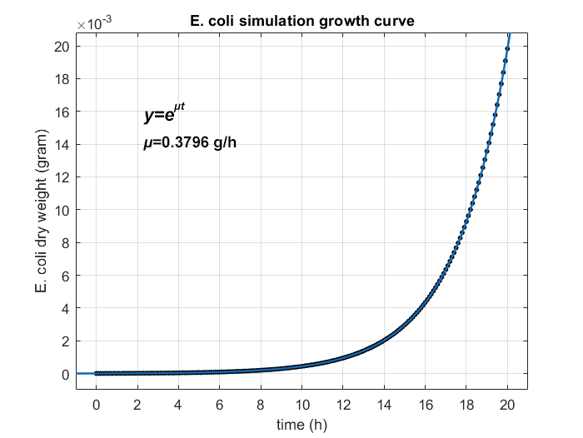

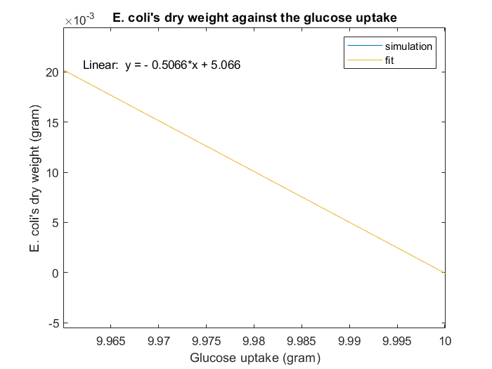

Figure Comparison of growth between simulation on E. coli GEM and reference value

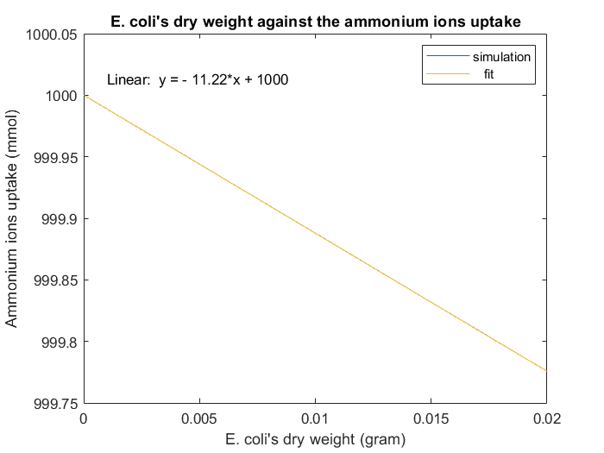

Figure

* 1. Modification

Then, we modify the model according to the metabolite pathway.

* 1. Dynamic-FBA

After that, we adjusted the parameters to fit the experiment data, and the simulation result of *E. coli*’s HCHO consumption is presented below.

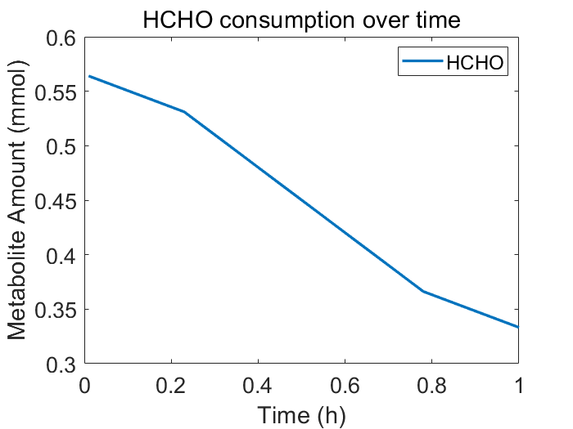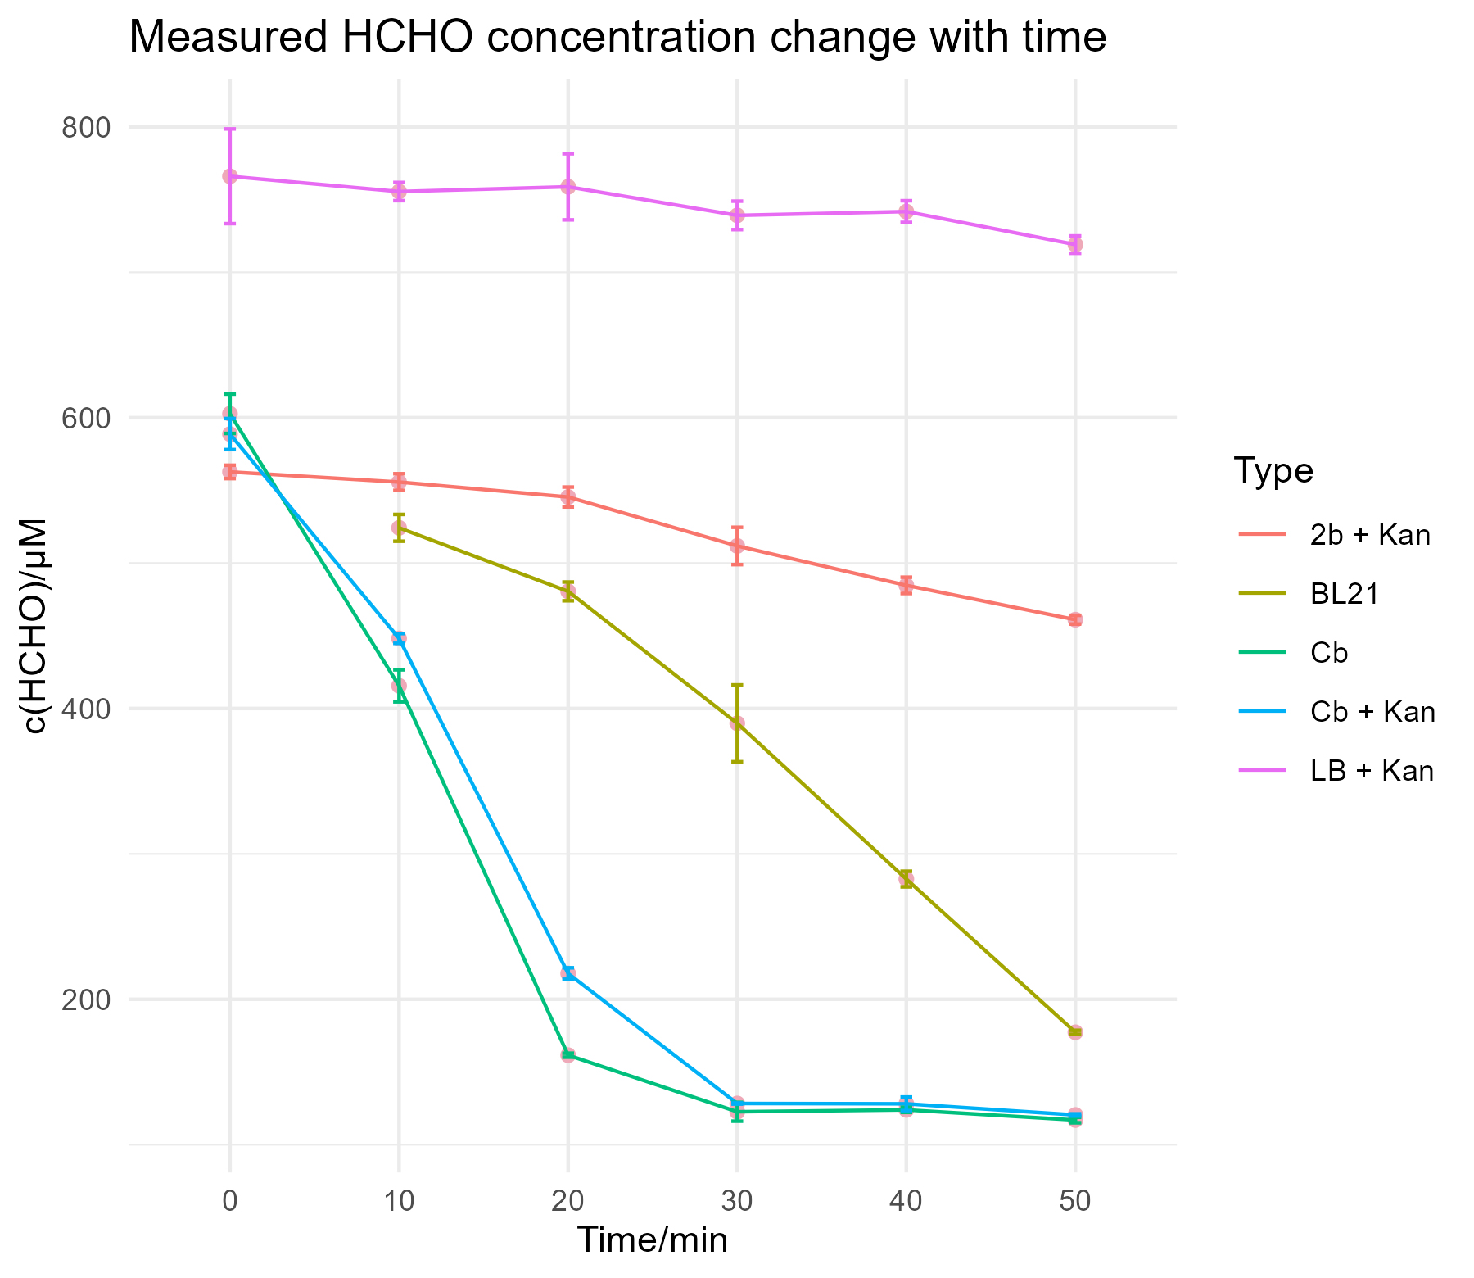

* 1. Multi-species dFBA (dynamic FBA)

This part gives a general idea of how the coculture system works.

1. Diffusion Model

This model is aimed at giving an insight into how alginate beads affect the metabolite of the microorganism embedded. In our project, we make three types of beads, one with blue algae for sucrose production, one with e. coli for sucrose degradation, and one with e. coli for formaldehyde degradation. During the development, we realized that we could increase the accuracy by the embedding ODE system, which describes the formaldehyde degradation pathway.

The model can be separated into two parts: diffusion and metabolite. We first developed the diffusion model and started a rough simulation, then combined the metabolite part with the diffusion model.

* 1. Metabolite function

Before we start, notice that one bead will only have one function, and we will not simulate multiple beads together for now.

* + 1. Formaldehyde measurement

The detection is based on the FrmR operon regulation on GFP, and the outcome is when formaldehyde is present, the beads will give green fluorescence under UV light.

Based on Hill’s equation (Woolston et al., 2018), we fit the curve to the experiment data, and the result is presented below.

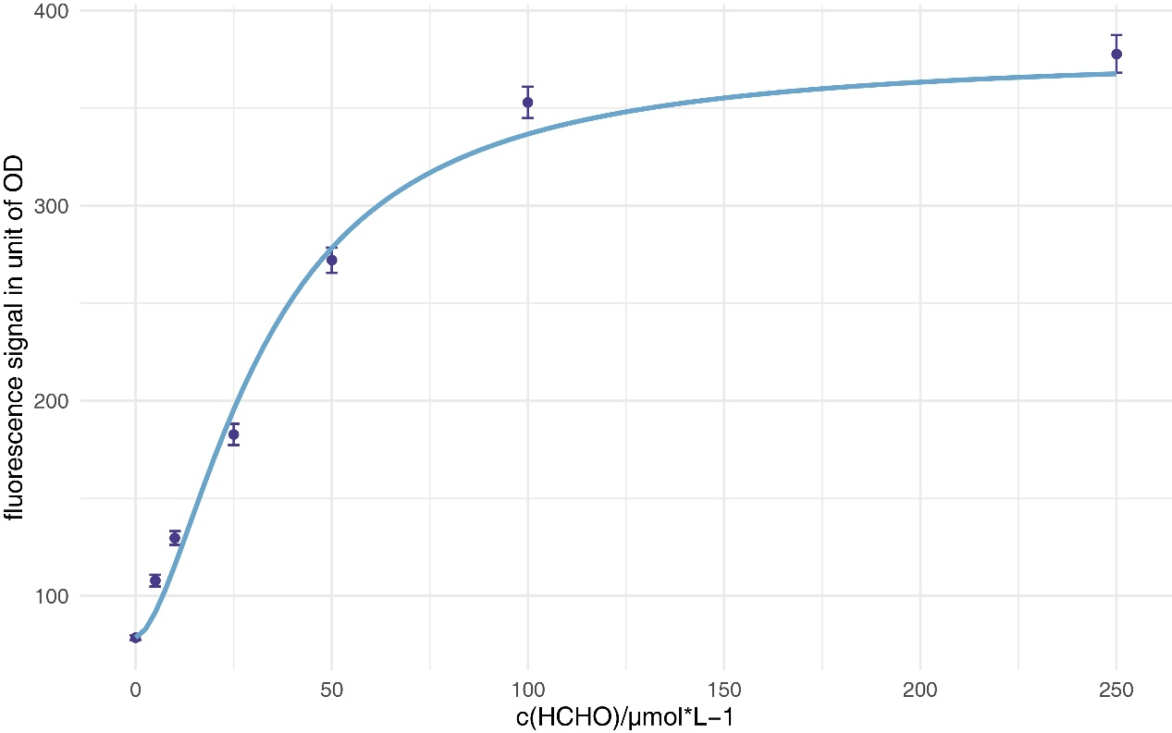

Fitted equation:

$$\begin{aligned}S=S_{min}+\left(S_{max}-S_{min}\right)×\frac{{\left[F\right]}^{n}}{K_{m}^{n}+{\left[F\right]}^{n}}\#\left( AUTONUM \backslash * Arabic \right)\end{aligned}$$

Where S represents the fluorescence signal, and [F] represents the formaldehyde concentration. The result met our expectations.

| **Parameters** | **Estimate** | **Std. error** | **P** |
| --- | --- | --- | --- |
| $$K_{m}$$ | 32.7494 | 2.5972 | 5.57e-05 *** |
| $$n$$ | 1.6467 | 0.1996 | 4.27e-04 *** |

* + 1. Formaldehyde degradation

The reason we use the ODE system to model this pathway again, after FBA, is that it is more convenient to build the ODE system into the simulation process.

(Wait to be integrated)

* + 1. Photosynthesis

We describe photosynthesis with the Michaelis-Menten equation and obtain the parameters through curve fitting with data from the wet lab.

* + 1. Sucrose hydrolysis
  1. Diffusion model

2.2.1 Mathematics

The diffusion model is based on Fick’s second law

$$\begin{aligned}\frac{∂c}{∂t}=\frac{∂^{2}c}{∂x^{2}}D\#\left( AUTONUM \backslash * Arabic \right)\end{aligned}$$

In three-dimension space, the formula can be rewrote with Laplacian operator

$$\begin{aligned}\frac{∂c}{∂t}=∇^{2}cD\#\left( AUTONUM \backslash * Arabic \right)\end{aligned}$$

Where $\begin{aligned}∇^{2}=\frac{∂^{2}}{∂x^{2}}+\frac{∂^{2}}{∂y^{2}}+\frac{∂^{2}}{∂z^{2}}\#\left( AUTONUM \backslash * Arabic \right)\end{aligned}$

Which means for a point, the unit change of concentration within unit time equals the point’s divergence times original concentration times the diffusion coefficient of the substance in a specific matter, in this case, the alginate is the matter.

The diffusion coefficient is related to the type of substance and the concentration of the medium, the numbers are given below.

| **Diffusion coefficient** | **Value($mm^{2}*s^{-1}$)** | **Substance** |
| --- | --- | --- |
| $$D_{sugar}​$$ | 1.73 | sucrose, glucose (Pu & Yang, 1988) |
| $$D_{f}$$ |  | formaldehyde |

This formula tells us how a substance diffuses into another quantitively, and more importantly, based on former work, we could set up a simulation with the finite element method (FEM).

2.2.2 FEM

This is the pure alginate bead simulation.



* 1. Result

The simulation was done with MATLAB.

The reason we did not further do the simulation of multiple beads is based on an assumption, that with the pump, the solution is well mixed in every moment.

* 1. Discussion

We developed an “alginate beads with microorganism embedded” model, and set up a mathematical simulation with the finite element method. The result showed that the system will reach homeostasis after a sufficient time, and the diffusion rate equals the consumption/production rate.

There are still many things to be done in the future. The cell growth is limited due to the volume of the beads, and the distribution inside the beads is uneven. There are still bricks left aside, thus we upload our commented MATLAB code and serve it as a rough framework for teams that wants to give FEM a try.

Christensen, M. L., & Eriksen, N. T. (2002). Growth and proton exchange in recombinant Escherichia coli BL21. *Enzyme and Microbial Technology*, *31*(4), 566-574. <https://doi.org/https://doi.org/10.1016/S0141-0229(02)00153-9>

Dukovski, I., Bajić, D., Chacón, J. M., Quintin, M., Vila, J. C. C., Sulheim, S., Pacheco, A. R., Bernstein, D. B., Riehl, W. J., Korolev, K. S., Sanchez, A., Harcombe, W. R., & Segrè, D. (2021). A metabolic modeling platform for the computation of microbial ecosystems in time and space (COMETS). *Nature Protocols*, *16*(11), 5030-5082. <https://doi.org/10.1038/s41596-021-00593-3>

Heirendt, L., Arreckx, S., Pfau, T., Mendoza, S. N., Richelle, A., Heinken, A., Haraldsdóttir, H. S., Wachowiak, J., Keating, S. M., Vlasov, V., Magnusdóttir, S., Ng, C. Y., Preciat, G., Žagare, A., Chan, S. H. J., Aurich, M. K., Clancy, C. M., Modamio, J., Sauls, J. T., . . . Fleming, R. M. T. (2019). Creation and analysis of biochemical constraint-based models using the COBRA Toolbox v.3.0. *Nature Protocols*, *14*(3), 639-702. <https://doi.org/10.1038/s41596-018-0098-2>

Monk, J. M., Charusanti, P., Aziz, R. K., Lerman, J. A., Premyodhin, N., Orth, J. D., Feist, A. M., & Palsson, B. Ø. (2013). Genome-scale metabolic reconstructions of multiple <i>Escherichia coli</i> strains highlight strain-specific adaptations to nutritional environments. *Proceedings of the National Academy of Sciences*, *110*(50), 20338-20343. <https://doi.org/10.1073/pnas.1307797110>

Orth, J., Thiele, I. & Palsson, B. (2010). What is flux balance analysis? *Nat Biotechnol*, *28*, 245–248.

Pu, H. T., & Yang, R. Y. (1988). Diffusion of sucrose and yohimbine in calcium alginate gel beads with or without entrapped plant cells. *Biotechnol Bioeng*, *32*(7), 891-896. <https://doi.org/10.1002/bit.260320707>

Woolston, B. M., Roth, T., Kohale, I., Liu, D. R., & Stephanopoulos, G. (2018). Development of a formaldehyde biosensor with application to synthetic methylotrophy. *Biotechnol Bioeng*, *115*(1), 206-215. <https://doi.org/10.1002/bit.26455>